Contents

System Requirements 2

Operating System 2

Libraries 2

Installation 2

Verification 2

Scope 2

In Scope 2

Out of Scope 3

Download Utility 3

Start the utility 3

Double Click 3

Command Prompt 4

Use Utility 4

Actions 4

Open File Chooser 4

Use Filter 5

Select CSV 6

Start Process 7

Output File 7

Resizing Utility 8

Minimizing Utility 8

Closing Utility 8

Known Errors 8

Not a CSV 8

Blank File 9

Image Path Missing 9

Image Path is wrong 10

Unknown Error 11

# System Requirements

## Operating System

This utility should be able to run on different versions of these OS but this has been verified on following.

1. Windows 10
2. Mac OS Mojave 10.14.6

## Libraries

This utility is built using Java, therefore to run it the computer should have Java run time environment of version “1.8.0_231-b11”.

### Installation

In case Java is not installed on the system where this utility is planned to run. One should download JRE (Java Run Time Environment) version “1.8.0_231-b11” from Oracle’s website, install it.

### Verification

To verify JRE version on the system, please run following command and verify.

Command: java -version

e.g.

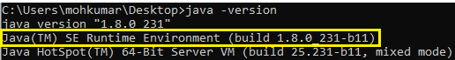

# Scope

## In Scope

This GUI will help you select input CSV and generate output CSV.

Input CSV format:

|  |  |
| --- | --- |
| image1 | image2 |
| aa.png | ba.png |
| ab.png | bb.png |
| ac.png | ac.gif |
| ad.png | bd.png |

Output CSV format:

|  |  |  |  |
| --- | --- | --- | --- |
| image1 | image2 | similar | elapsed |
| aa.png | ba.png | 0 | 0.006 |
| ab.png | bb.png | 0.23 | 0.843 |
| ac.png | ac.gif | 0 | 1.43 |
| ad.png | bd.png | 1 | 2.32 |

## Out of Scope

This tool does not allow to prepare, edit, and download CSV.

# Download Utility

To use this utility one should download its latest version of executable JAR from executable directory of GIT of this repository.

<RepositoryHome>/executable can contain multiple versions of JAR, one should download the JAR from latest version directory. Version-2 version is latest than Version-1 and so on.



If one wishes to see the changes included in a specific version, following file should have that information.

<RepositoryHome>/executable/<version>/changelog.txt

e.g.



# Start the utility

## Double Click

To start this utility one should double click the downloaded JAR. In case this does not work, please use next method.

## Command Prompt

Open command prompt, navigate to directory where JAR was downloaded in previous steps. Then, Execute following command.

Command: java -jar ImageComparision.jar

# Use Utility

Once you start the application, you should see a GUI (Graphical User Interface) like below.

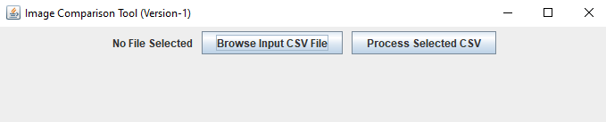

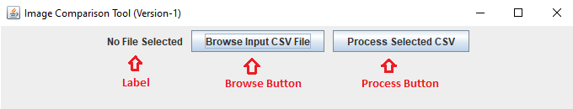

|  |  |
| --- | --- |
| **Element** | **Description** |
| Label | Used to show selected file, user messages, error messages. |
| Browse Button | Used to open file chooser, to select input file |
| Process Button | Process records in input file and generates output file |

## Actions

### Open File Chooser

Click Browse button to open file chooser, to then select CSV.

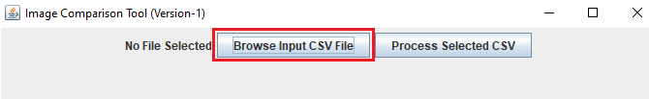

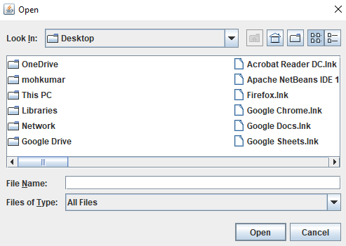

### Use Filter

CSV filter can be used to see just CSV files on file system. However this is optional, you may select the CSV without using this feature.

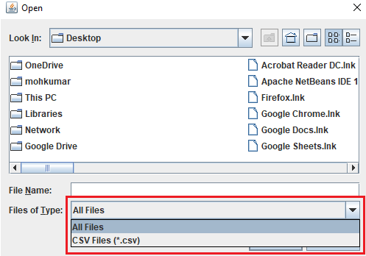

### Select CSV

Navigate to directory where you have your input CSV and select CSV.

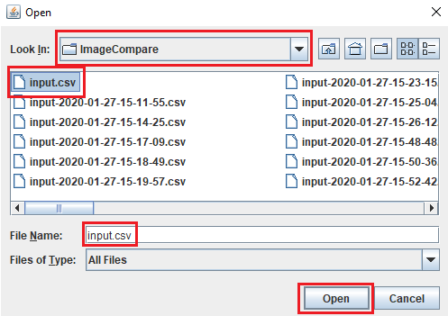

Once you select CSV, it would appear on the utility

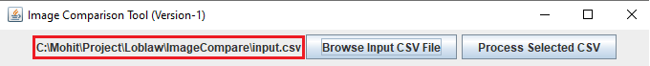

### Start Process

Once you have selected input CSV, you may start image comparison process by clicking process button.

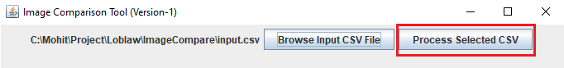

### Output File

Once the process is complete from previous step, you will find complete path to the output CSV, displayed on the utility.

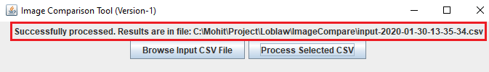

Output file is generated in same directory as of input directory. Output file name is Input file name with time stamp.

Output file name = <Input File Name>-YYYY-MM-DD-HH-MM-SS

Example of output file:



Example of content of output file:



### Resizing Utility

It might happen that file path is very long and does not fit in GUI of the utility. In that case you may resize the utility by stretching it from the side or bottom borders.

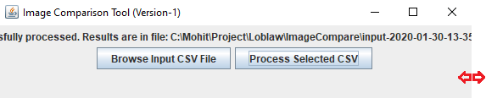

### Minimizing Utility

At any point of time you want to minimize this utility to go to some other application or window, you may minimize this utility using the highlighted button.

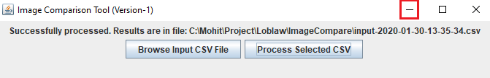

### Closing Utility

To close the application, please use the highlighted button.

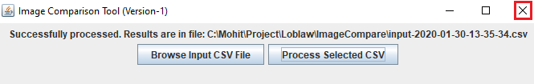

## Known Errors

### Not a CSV

In case you did not use the built CSV filter and select any file other than CSV and run the process. You would see an error suggesting that you should select a CSV file.

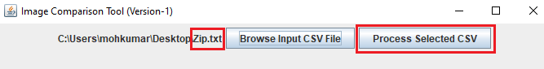

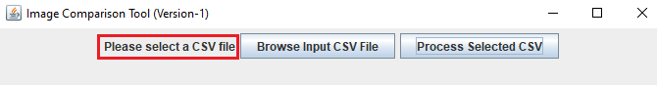

### Blank File

In case you run the process which is completely empty, you would find an error mentioning file is blank.



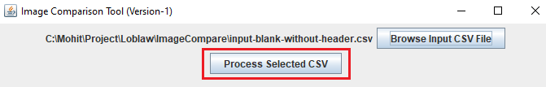

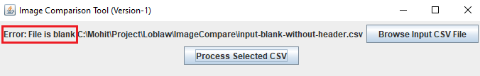

### Image Path Missing

In case input file does not have image path in first or second column. Process would run for rest of the rows in input file, but for the faulty rows you would see an error in output file.

Input File:

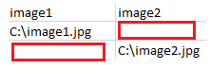

Output File:

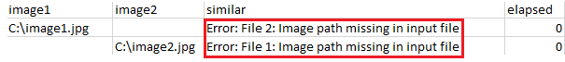

### Image Path is wrong

In case input file has image paths in column one or two which do not exist on file system. Process would run for rest of the rows in input file, but for the faulty rows you would see an error in output file.

Input File:

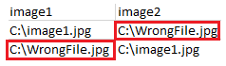

Output File:



## Unknown Error

In case an error is not handled and something is going wrong while using the utility, you will find a general exception. To fix this maintainer of the application should be contacted.

